



WebMinds, Inc.

NetOptimizerTM

Version v5.0

User Manual

Version 1.0

Feb 21, 2012

Copyright © WebMinds, Inc., 2024

All Rights Reserved

This publication is protected by federal copyright law. No part of this publication may be copied or distributed, stored in a retrieval system, or translated into any human or computer language in any form or by any means, electronic, mechanical, magnetic, manual or otherwise, or disclosed to third parties without the express written permission of **WebMinds, Inc.**

**WebMinds, Inc.** makes no representation or warranties with respect to the contents hereof and specifically disclaim any implied warranties of merchantability or fitness for a particular purpose. Further, **WebMinds, Inc.** reserves the right to revise this publication and to make changes from time to time in the contents hereof without obligation of **WebMinds, Inc.** to notify any person or organization of such revision or changes.

**WebMinds, Inc.** has prepared this guide for use by **WebMinds, Inc.** personnel and authorized third parties as a guide to proper operation and/or maintenance of **WebMinds, Inc.** equipment and software. The drawings and specifications contained herein are the property of **WebMinds, Inc.**

Trademarked names may appear throughout this document. Rather than list the names and entities that own the trademarks or insert a trademark symbol with each mention of the trademarked name, the names are used only for editorial purposes and to the benefit of the trademark owner with no intention of infringing upon that trademark.

Address comments and corrections to:

**WebMinds, Inc.**

950 N Collier Blvd. Suite 400

Marco Island FL 34145

USA

Revision History

|  |  |  |  |
| --- | --- | --- | --- |
| Date | Release | Revision DESCRIPTION | MODIFIED BY |
| Dec 20, 2024 | 0.1 | Initial draft | David A. Flynn |
| Dec 20, 2024 | 1.0 | First base lined document | David A. Flynn |
|  |  |  |  |
|  |  |  |  |
|  |  |  |  |
|  |  |  |  |

About this Document

This section briefly describes key details of this document –

Purpose of this Document

The purpose of this document is to assist end users of the NetOptimizerTM application.

Scope of this Document

The section describes the topics in and out of scope of this document –

In Scope

The scope of this document includes the description and usage of the NetOptimizerTM application.

Out of Scope

The scope of this document does not include –

* the detailed installation process of NetOptimizerTM application
* the usage of the features and functionalities of your operating system

Intended Audience of this Document

The intended audiences of this document are –

* end users of the NetOptimizerTM application

Typographical Conventions / Customaries used in this Document

The typographical conventions used in this document include the following –

* **Note:** The purpose of this typographical convention is to provide important information corresponding to an already stated fact. This is we depict a note in this document –

**Note:**<Note Text><Note Text><Note Text><Note Text><Note Text><Note Text><Note Text><Note Text><Note Text><Note Text><Note Text><Note Text><Note Text><Note Text>

* **Tip:** The purpose of this typographical convention is to provide additional information supplementing an already stated fact. This is how we depict a tip in this document –

**Tip:**<Tip Text><Tip Text><Tip Text><Tip Text><Tip Text><Tip Text><Tip Text><Tip Text><Tip Text><Tip Text><Tip Text><Tip Text><Tip Text><Tip Text><Tip Text><Tip Text><Tip Text>

* **Warning:** The purpose of this typographical convention is to provide critical information corresponding to an already stated fact. This is how we depict a warning in this document –

**Warning:**<Warning Text><Warning Text><Warning Text><Warning Text><Warning Text><Warning Text><Warning Text><Warning Text><Warning Text><Warning Text><Warning Text>

* **Reference:** The purpose of this typographical convention is to refer you to another section in this document or another document or to an external reference. A reference is depicted in the following manner in this document –

**Reference:** To read detailed steps, navigate to **<Chapter Name>** chapter by clicking this link.

Abbreviations / Acronyms used in this Document

The table below describes the abbreviations / acronyms used in this document –

|  |  |
| --- | --- |
| Abbreviation | Description |
| **GUI, UI** | Graphical User Interface, User Interface |
| **IPR** | Intellectual Property Rights |
| **NO** | NetOptimizer |
| **TM** | Trade Mark |
| **TOC, TOT, TOF** | Table of Contents, Table of Tables, Table of Figures |

Organization of this Document

This document contains 6 chapters as indicated below –

|  |  |
| --- | --- |
| chapter | Description |
| **Chapter 1** | Introduction |
| **Chapter 2** | Getting Started |
| **Chapter 3** | Using the Auto Mode |
| **Chapter 4** | Using the Advanced Mode |
| **Chapter 5** | Viewing the Wi-Fi Passwords |
| **Chapter 6** | Using the Browser Cleanup Feature |
| **Chapter 7** | Using the Diagnostic Troubleshooting Feature |
| **Chapter 8** | Activating your NetOptimizer TM Installation |
| **Chapter 9** | Removing your NetOptimizer TM License Key |

Terms Used in this Document

The below table briefly describes the terms utilized in this document –

| chapter | Description |
| --- | --- |
| **End User** | An operator or user of the NetOptimizer TM application. |

Table of Contents

Revision History ii

About this Document iii

Purpose of this Document iii

Scope of this Document iii

In Scope iii

Out of Scope iii

Intended Audience of this Document iii

Typographical Conventions / Customaries used in this Document iv

Abbreviations / Acronyms used in this Document v

Organization of this Document v

Terms Used in this Document v

Table of Contents 6

Table of Figures 7

Chapter - 1. Introduction 8

Chapter - 2. Getting Started 9

Chapter - 3. Using the Auto Mode 11

Chapter - 4. Using the Advanced Mode 14

4.1 Optimizing Data Caching Settings 15

4.2 Optimizing DNS Server Settings 15

4.3 Optimizing 15

4.4 Optimizing 15

4.5 Optimizing 15

4.6 Optimizing 15

4.7 Optimizing 15

4.8 Optimizing 15

4.9 Optimizing 15

4.10 Optimizing 16

4.11 Optimizing 16

Chapter - 5. Viewing the Wi-Fi Passwords 17

Chapter - 6. Using the Browser Cleanup Feature 18

Chapter - 7. Using the Diagnostic Troubleshooting Feature 21

Chapter - 8. Activating your NetOptimizerTM Installation 22

Chapter - 9. Removing your NetOptimizerTM License Key 24

Index 26

Table of Figures

Figure 1 – Downloading the NetOptimizerTM application installer executable file 8

Figure 2 – NetOptimizerTM default screen 9

Figure 3 – Running the Auto Mode wizard 11

Figure 4 – Automatic execution of the Auto Mode system analysis wizard 11

Figure 5 – Apply optimized network settings? 12

Figure 6 – Key application popup 12

Figure 7 – Successful application of your license key 13

Figure 8 – Restarting your system 13

Figure 9 – Using the Advanced Mode 14

Figure 10 – Automatic execution of the Auto Mode system analysis wizard 14

Figure 11 – Viewing the Wi-Fi Passwords 17

Figure 12 – Automatic execution of the Auto Mode system analysis wizard 17

Figure 13 – Using the Browser Cleanup Feature 18

Figure 14 – Browser cleanup screen 18

Figure 15 – Querying for Cleanup task confirmation 19

Figure 16 – Querying for closing open web-browsers 19

Figure 17 – Successful Operation completion status message 20

Figure 18 – Browser cleanup screen 20

Figure 19 – Using the Diagnostic Troubleshooting Feature 21

Figure 20 – Diagnostic troubleshooting wizard 21

Figure 21 – Activating your NetOptimizerTM Installation 22

Figure 22 – Key application popup 22

Figure 23 – Successful application of your license key 23

Figure 24 – Viewing your license key details 23

Figure 25 – Removing your NetOptimizerTM License Key 24

Figure 26 – Viewing your license key details 24

Figure 27 – License key deactivation confirmation message 25

Figure 28 – License key deactivation successfully status message 25

# Introduction

In today’s digital age, a slow wifi connection can be a major source of frustration. Whether you’re trying to stream your favorite show, work from home, or simply browse the internet, a sluggish connection can bring everything to a halt.

**Reference:** To read about common issues which may contribute to slowing your wifi connection, visit [**https://www.netoptimizer.com/how-to-fix-slow-wifi/**](https://www.netoptimizer.com/how-to-fix-slow-wifi/)

Once you are sure that all of the issues mentioned in the article above have been taken care off, you can download the NetOptimizer TM application from the **Download** link available in the menu on the NetOptimizer TM homepage or by clicking the **Free Download** button as depicted in the figure below –

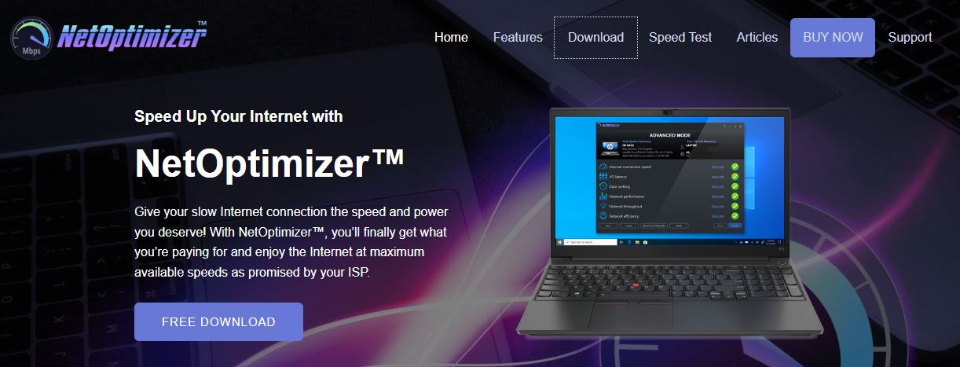

Figure 1 – Downloading the NetOptimizerTM application installer executable file

**Tip:** After you click the above-mentioned links, you may be warned by your web-browser about a potential security risk due to the downloaded executable file. Please authorize this file.

You can follow the installation wizard by launching the downloaded NetOptimizer TM installer executable file to install the NetOptimizer TM application on your system.

**Tip:** After you open the downloaded executable file, you may be warned by your operating system before you install this application on your system. Please authorize your operating system to continue installing this application at this step.

The next chapter describes steps that enable you to get started with the NetOptimizer TM application.

# Getting Started

After you launch the NetOptimizer application, your internet summary details are fetched and the default screen is displayed as depicted in the figure below –

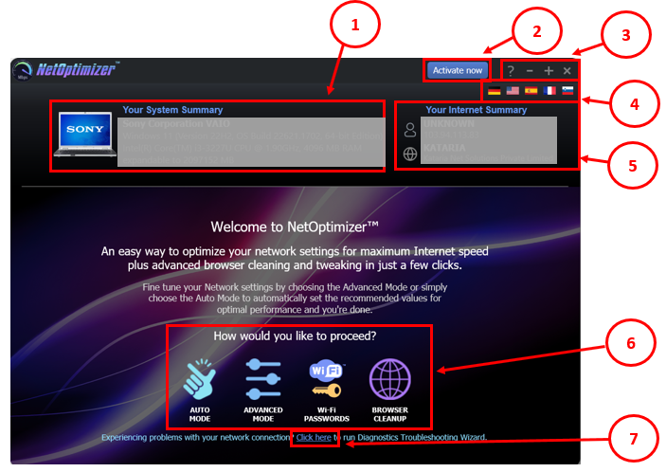

Figure 2 – NetOptimizerTM default screen

Below is a description of the screen elements of the default screen of the NetOptimizerTM application.

| **NO.** | **DESCRIPTION** |
| --- | --- |
| **1** | This section of the screen displays your system summary details. |
| **2** | Clicking the **Activate Now** button enables you to activate your subscription plan by specifying your email address and the key provided to you after you purchase a subscription plan suitable to you.  **Reference:** To read the detailed steps, navigate to **Activating your NetOptimizerTM Installation** chapter by clicking this link. |
| **3** | Below are the descriptions of the buttons available in this section of the screen –   * **Question Mark (?)** – Clicking this button opens the **About** popup which displays the details of your NetOptimizer installation. E.g. license details, etc. * **Minus (-)** – Clicking this button enables you to minimize this screen * **Plus (+)** – Clicking this button enables you to maximize this screen * **Cross (x)** – Clicking this button enables you to close this screen |
| **4** | Clicking any of the national flags enables you to change the display language of your NetOptimizer installation. |
| **5** | This section of the screen displays your internet summary details. |
| **6** | Below are the descriptions of the buttons available in this section of the screen –   * **Auto Mode** – Clicking this button enables you to run the NetOptimizer TM wizard in automatic mode.   **Reference:** To read detailed steps, navigate to **Using the Auto Mode** chapter by clicking this link.   * **Advanced Mode** – Clicking this button enables you to run the NetOptimizer TM wizard in advanced mode   **Reference:** To read detailed steps, navigate to **Using the Advanced Mode** chapter by clicking this link.   * **Wi-Fi Passwords** – Clicking this button enables you to view the password of the wifi connection that your system is connected to.   **Reference:** To read detailed steps, navigate to **Viewing the Wi-Fi Passwords** chapter by clicking this link.   * **Browser Cleanup** – Clicking this button enables you to clean up the cache memory of the web browser of your choice   **Reference:** To read detailed steps, navigate to **Using the Browser Cleanup Feature** chapter by clicking this link. |
| **7** | **Diagnostic Troubleshooting** – Clicking this link enables you to launch the Network Diagnostic Troubleshooting wizard of your operating system.  **Reference:** To read the detailed steps, navigate to **Using the Diagnostic Troubleshooting Feature** chapter by clicking this link. |

The next chapter describes steps that enable you to use the **Auto Mode** of the NetOptimizer TM application.

# Using the Auto Mode

The steps described below enable you to use the automatic mode of the NetOptimizerTM application –

1. From the default screen of the NetOptimizerTM application, click the **Auto Mode** button as depicted in the figure below.

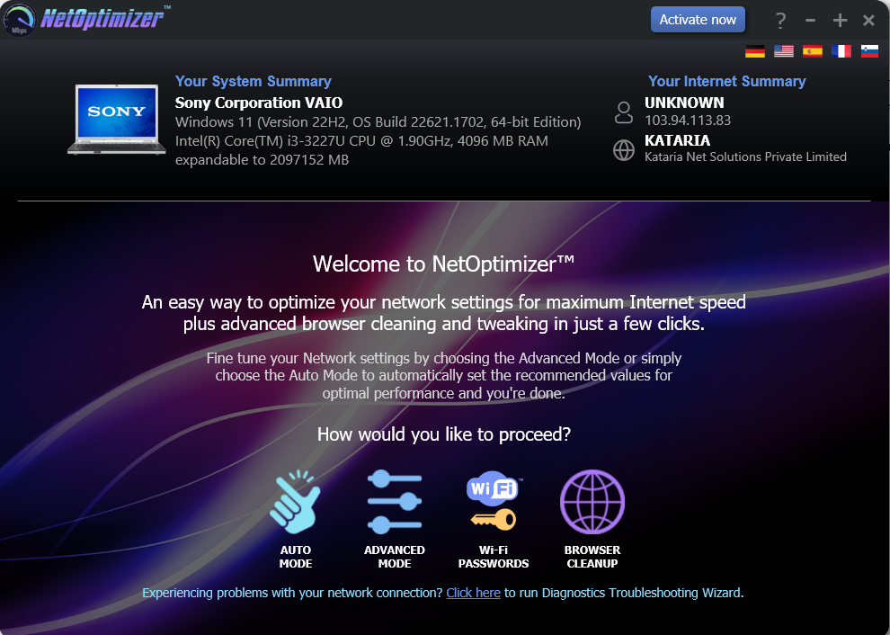

SANITIZED

SANITIZED

Figure 3 – Running the Auto Mode wizard

The Auto Mode screen is displayed as depicted in the figure below –

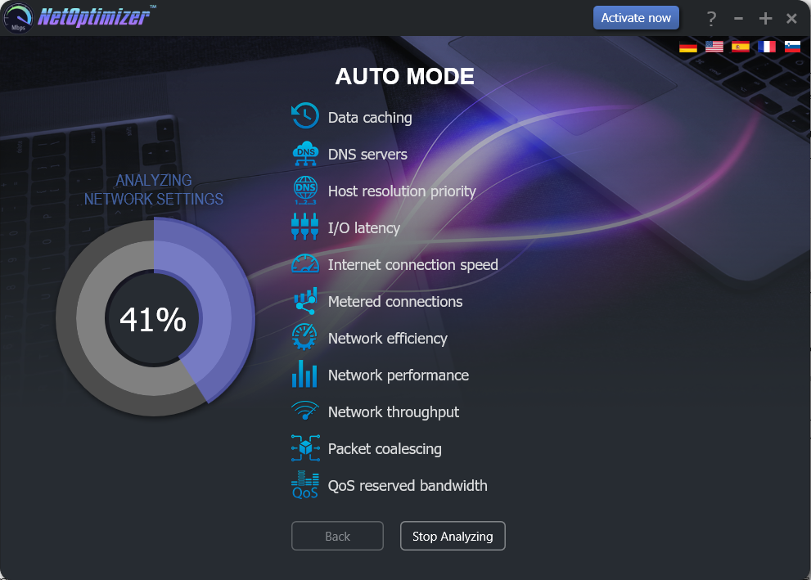

Figure 4 – Automatic execution of the Auto Mode system analysis wizard

The wizard starts analyzing your system as soon as this screen is loaded.

**Tip:** To stop Analyzing your system click **Stop Analyzing** as depicted in the figure above. You can also navigate to the default screen by clicking the **Back** button after the analysis has stopped or completed.

1. After the wizard has analyzed your system, the optimized network settings choice popup is displayed as depicted in the figure below –

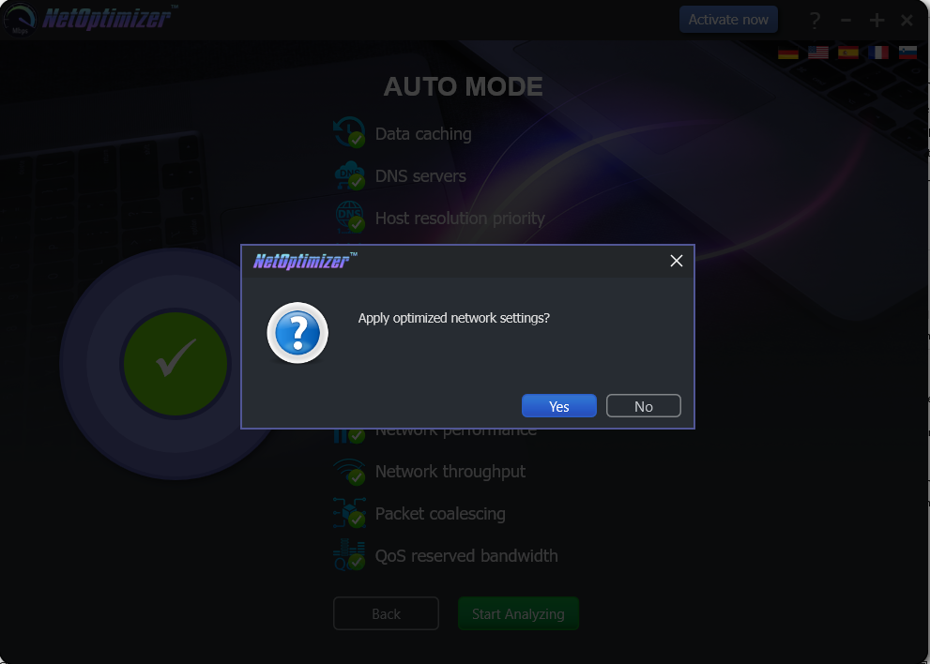

Figure 5 – Apply optimized network settings?

Click **No** in case you would like to manually change required options before you apply each optimized setting.

**Reference:** For more information, refer to **Using the Advanced Mode** chapter by clicking this link.

Click **Yes** to continue applying the optimized network settings.

1. In case you have not purchased and applied a license key in your NetOptimizerTM application installation, a key application popup is displayed as depicted in the figure below –

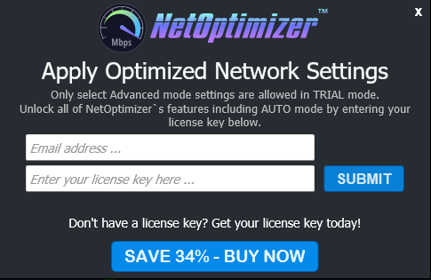

Figure 6 – Key application popup

1. Click the **Buy Now** button to avail the money saving offer depicted here.

**Tip:** You will be navigated to the NetOptimizerTM shopping cart web page in your default web browser. You can specify the required details, and click **Buy Now** on this web page to make your purchase. You will receive an email containing your license key details at the email address specified by you on this web page.

1. Once you have received your license key, specify your email address and license key and click the **Submit** button. After successful validation of the specified key, your NetOptimizerTM installation will be activated and a popup will be displayed confirming the same as depicted in the figure below -

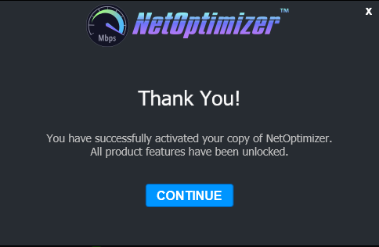

Figure 7 – Successful application of your license key

1. Click **Continue** to continue using the NetOptimizerTM application. The application will create a restore point in your operating system and your optimized network settings will be applied. The application will also query you whether you would like to restart the system as depicted in the figure below.

**Tip:** The system needs to be restarted to apply the optimized network settings completely and to be loaded by your operating system.

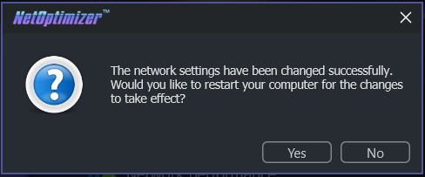

Figure 8 – Restarting your system

1. Click **Yes** to restart your system.

The next chapter describes steps that enable you to use the **Advanced Mode** of the NetOptimizer TM application.

# Using the Advanced Mode

The steps described below enable you to use the advanced mode of the NetOptimizerTM application –

1. From the default screen of the NetOptimizerTM application, click the **Advanced Mode** button as depicted in the figure below.



SANITIZED

SANITIZED

Figure 9 – Using the Advanced Mode

The Advanced Mode screen is displayed as depicted in the figure below –

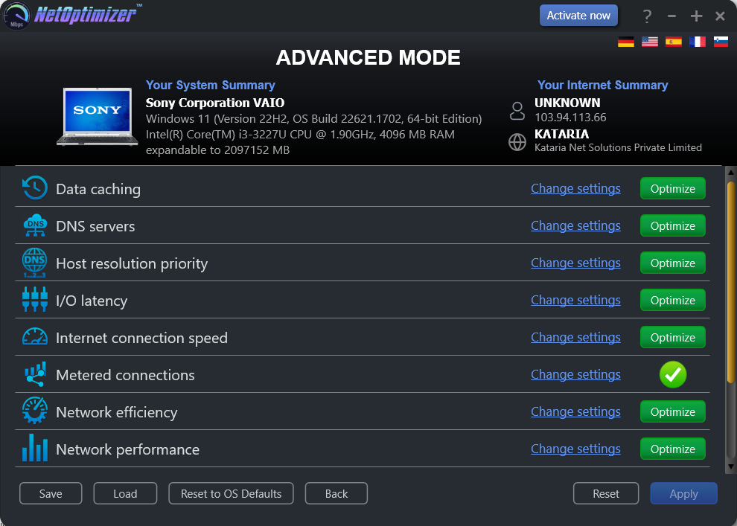

Figure 10 – Automatic execution of the Auto Mode system analysis wizard

Follow the steps described in each of the following sub-sections to perform each network optimization task of your system.

## Optimizing Data Caching Settings

## Optimizing DNS Server Settings

## Optimizing

## Optimizing

## Optimizing

## Optimizing

## Optimizing

## Optimizing

## Optimizing

## Optimizing

## Optimizing

The next chapter describes steps that enable you to view the **Wi-Fi Passwords** of the wifi connection that your system is connected to.

# Viewing the Wi-Fi Passwords

The steps described below enable you to view the wifi password of the connection that your system is connected to –

1. From the default screen of the NetOptimizerTM application, click the **Wi-Fi Passwords** button as depicted in the figure below.



SANITIZED

SANITIZED

Figure 11 – Viewing the Wi-Fi Passwords

The Wi-Fi Passwords screen is displayed as depicted in the figure below –

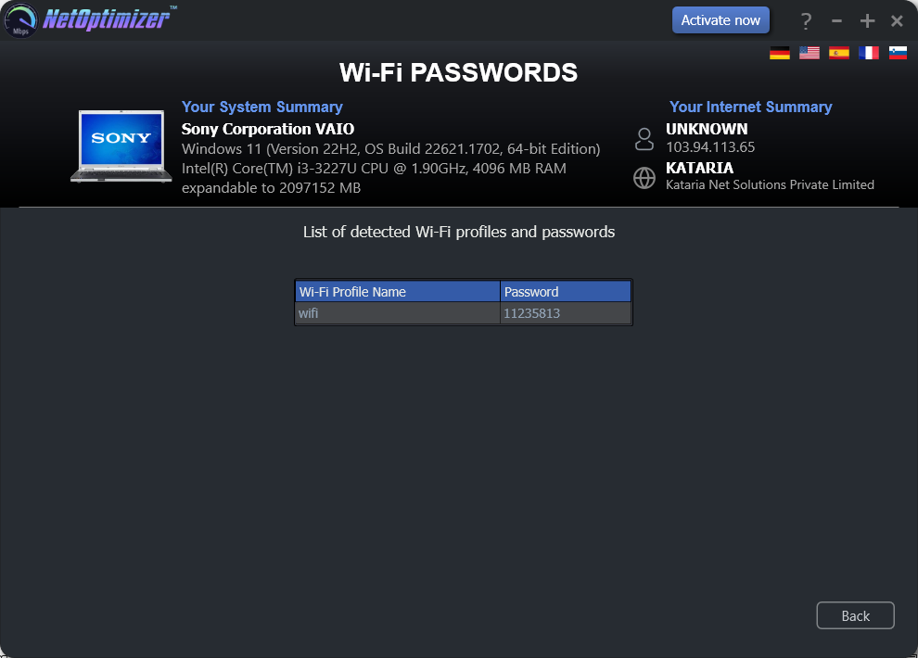

SANITIZED

SANITIZED

Figure 12 – Automatic execution of the Auto Mode system analysis wizard

1. Click **Back** to return to the NetOptimizerTM default screen.

The next chapter describes steps that enable you to use the **Browser Cleanup** feature of the NetOptimizer TM application.

# Using the Browser Cleanup Feature

The steps described below enable you to use the browser cleanup feature of the NetOptimizerTM application –

1. From the default screen of the NetOptimizerTM application, click the **Browser Cleanup** button as depicted in the figure below.



SANITIZED

SANITIZED

Figure 13 – Using the Browser Cleanup Feature

The Browser Cleanup screen is displayed as depicted in the figure below –

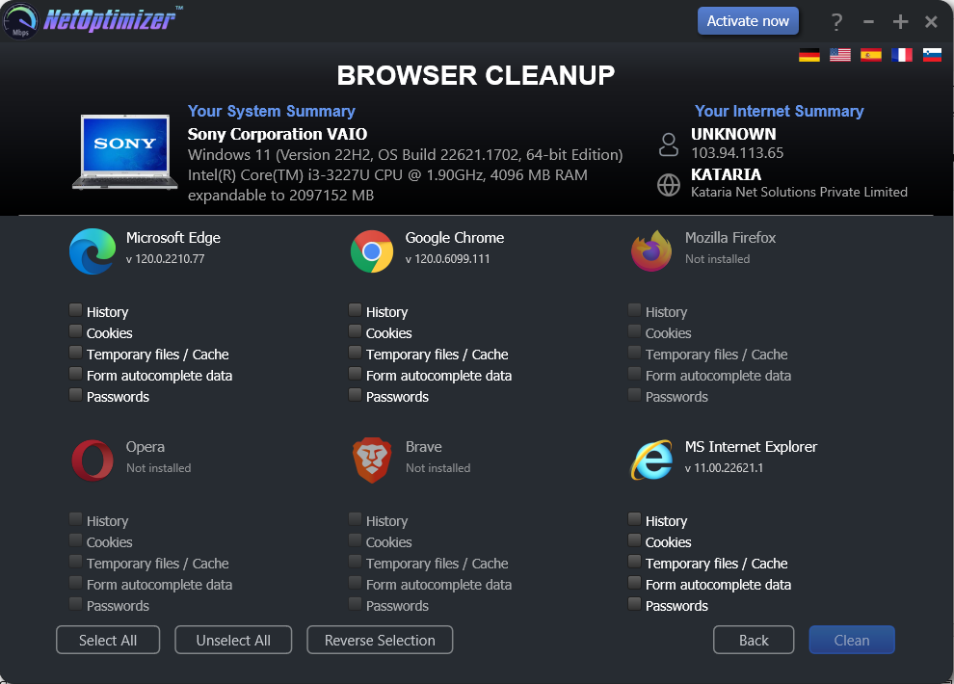

SANITIZED

SANITIZED

Figure 14 – Browser cleanup screen

1. You can specify which cleaning tasks are to be performed by clicking the corresponding checkboxes for each browser one-by-one or you can click the **Select** **All** button to select all checkbox options. You can also click **Unselect** **All** to unselect any or all checkboxes that you may have previously selected or you can click **Remove** **Selection** to remove your selections.

**Tip:** You can only select corresponding options for the web-browsers that are installed on your system. The Clean button will only be enabled once you make at least one selection for the installed browser of your choice.

1. Click **Clean** to clean your web browsers as per your selections. The NetOptimizerTM application will query you to continue the cleanup procedure as per your selections as depicted in the figure below –

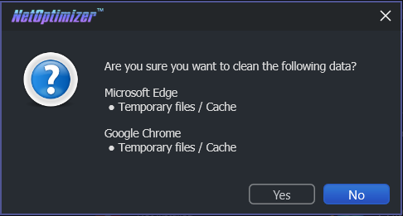

Figure 15 – Querying for Cleanup task confirmation

1. Click **Yes** to continue cleaning up the specified web-browser(s) or click **No** abort continuing with this cleanup task.

**Tip:** You can change your selections by repeating steps 2 and 3 described in this section or you can click **Back** to return the NetOptimizerTM default screen.

1. In case your web-browsers are open, the application will prompt you to close them as depicted in the figure below –

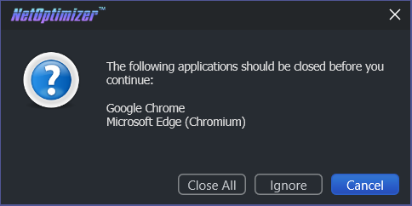

Figure – Querying for closing open web-browsers

1. Click **Close All** to close your web-browsers.

**Tip:** Click **Ignore** to perform the cleanup task without closing your web-browsers.

Once the cleanup task has been completed, a popup confirming the same will be displayed as depicted in the figure below –

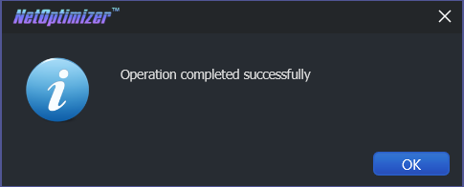

Figure – Successful Operation completion status message

1. Click **OK** to continue. You will be viewing the Browser Cleanup screen as depicted in the figure below-



SANITIZED

SANITIZED

Figure – Browser cleanup screen

1. Click **Back** to return to the NetOptimizerTM default screen.

The next chapter describes steps that enable you to use the **Diagnostic Troubleshooting** feature of the NetOptimizer TM application.

# Using the Diagnostic Troubleshooting Feature

The steps described below enable you to use the diagnostic troubleshooting feature of your system –

1. From the default screen of the NetOptimizerTM application, click the **Click here** link as depicted in the figure below.



SANITIZED

SANITIZED

Figure 19 – Using the Diagnostic Troubleshooting Feature

The Diagnostic Troubleshooting screen is displayed as depicted in the figure below –

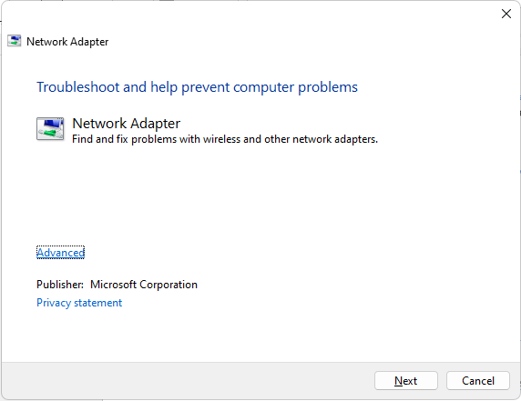

Figure 20 – Diagnostic troubleshooting wizard

1. Click **Next** to execute the Diagnostic Troubleshooting wizard or click **Cancel** to return to the NetOptimizerTM default screen.

**Tip:** For more information, refer to the user manual of your operating system.

The next chapter describes steps that enable you to Activate your NetOptimizerTM installation.

# Activating your NetOptimizerTM Installation

In case you have not activated your NetOptimizerTM application while using the Auto Mode network optimization wizard, you can utilize the steps described below which enable you to activate your NetOptimizerTM application installation –

1. From the default screen of the NetOptimizerTM application, click the **Activate Now** button as depicted in the figure below.



SANITIZED

SANITIZED

Figure 21 – Activating your NetOptimizerTM Installation

The Key Application popup is displayed as depicted in the figure below –



Figure – Key application popup

1. Click the **Buy Now** button to avail the money saving offer depicted here.

**Tip:** You will be navigated to the NetOptimizerTM shopping cart web page in your default web browser. You can specify the required details, and click **Buy Now** on this web page to make your purchase. You will receive an email containing your license key details at the email address specified by you on this web page.

1. Once you have received your license key, specify your email address and license key and click the **Submit** button. After successful validation of the specified key, your NetOptimizerTM installation will be activated and a popup will be displayed confirming the same as depicted in the figure below –



Figure – Successful application of your license key

1. Click **Continue** to continue using the NetOptimizerTM application. The Activate Now button will be removed from the NetOptimizerTM default screen.

**Tip:** To view the license details, you can click the **Question Mark (?)** button on the NetOptimizerTM default screen.

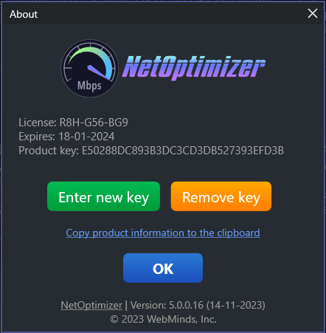

SANITIZED

Figure – Viewing your license key details

1. Click **Enter New Key** in case you intend to specify a new license key or click **OK** to continue using the NetOptimizerTM application.

**Tip:** Click the **Copy product information to the clipboard** link to copy the license details. You can paste this key in a document of your choice for safekeeping.

The next chapter describes steps that enable you to Remove your NetOptimizerTM license key.

# Removing your NetOptimizerTM License Key

Once you have activated your NetOptimizerTM application with a valid license key which has not expired yet, you can utilize the steps described below which enable you to remove this key so that you can reuse it on another system or the same system at a later date provided it has not expired –

1. From the default screen of the NetOptimizerTM application, click the **Question Mark (?)** button as depicted in the figure below.

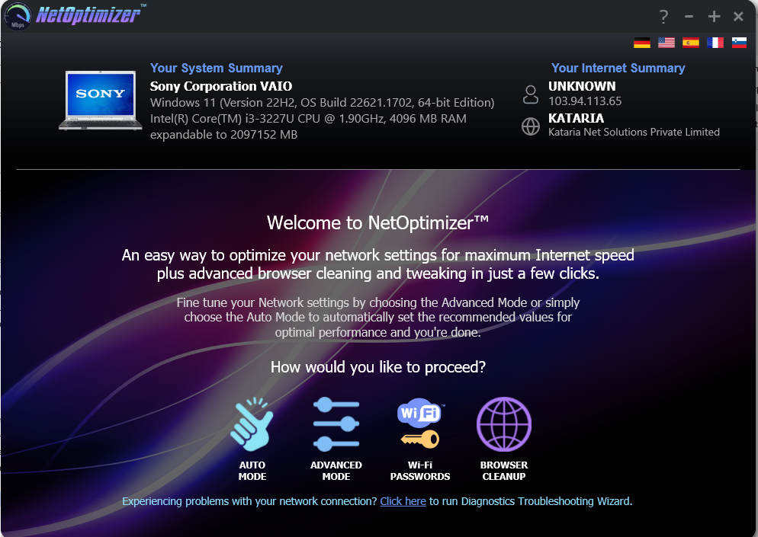

SANITIZED

SANITIZED

Figure 25 – Removing your NetOptimizerTM License Key

The About popup is displayed as depicted in the figure below –



SANITIZED

Figure – Viewing your license key details

1. Click **Remove Key** to remove your license key.

**Tip:** Click the **Copy product information to the clipboard** link to copy the license details. You can paste this key in a document of your choice for safekeeping.

1. After you have clicked on **Remove Key**, the application will query you for your confirmation as depicted in the figure below –

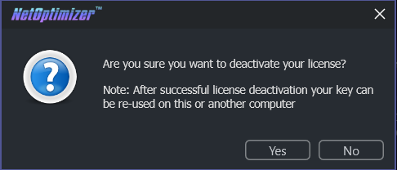

Figure – License key deactivation confirmation message

1. Click **Yes** to continue to deactivating your license key or click **No** to continue using your already specified license key. If you clicked **Yes**, a deactivation successful status message will be displayed as depicted in the figure below –

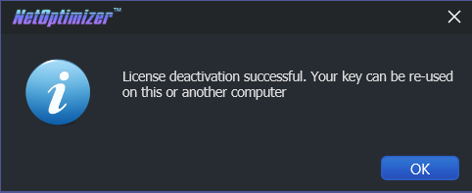

Figure – License key deactivation successfully status message

1. Click **Ok** to continue using the NetOptimizerTM application.

The next section of this document lists an index describing key points of this document. This information navigation aid enables you to quickly lookup required information.

Index

A

Abbreviations / Acronyms used in this Document v

About this Document iii

Activating your NetOptimizerTM Installation 22

G

Getting Started 9

I

In Scope iii

Intended Audience of this Document iii

Introduction 8

O

Optimizing 15, 16

Optimizing Data Caching Settings 15

Optimizing DNS Server Settings 15

Organization of this Document v

Out of Scope iii

P

Purpose of this Document iii

R

Removing your NetOptimizerTM License Key 24

S

Scope of this Document iii

T

Terms Used in this Document v

Typographical Conventions / Customaries used in this Document iv

U

Using the Advanced Mode 14

Using the Auto Mode 11

Using the Browser Cleanup Feature 18

Using the Diagnostic Troubleshooting Feature 21

V

Viewing the Wi-Fi Passwords 17